Taking down Next G PRs and News Articles:

[2/10/2022 10:51 AM] Hank Daugherty
sure

[2/10/2022 10:51 AM] Hank Daugherty
https://nextgalliance.org/wp-admin/edit.php?post_type=press-releases
FMG Representative Login

[2/10/2022 10:52 AM] Hank Daugherty
just throw those suckers in the trash if they get screwed up 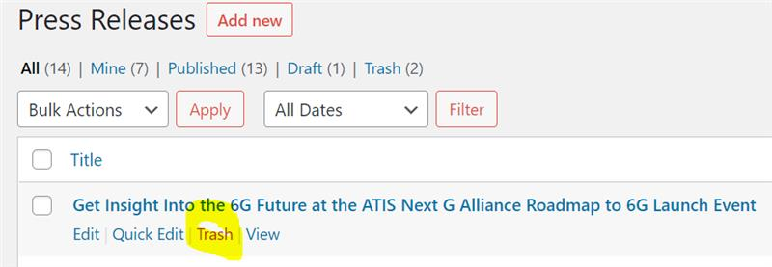

[2/10/2022 10:52 AM] Marcella Wolfe
Looks easy enough. I will keep that link and use it in future.

[2/10/2022 10:52 AM] Hank Daugherty
https://nextgalliance.org/wp-admin/edit.php?post_type=news-links that's the one for In the News
FMG Representative Login

[2/10/2022 10:53 AM] Marcella Wolfe
Making a mini users manual now, so I can throw the suckers in the trash if need be. Awesome.
like 1

[2/11/2022 2:26 PM] Marcella Wolfe
Are the presos from the Roadmap to 6G launch event going to be archived and available for public viewing after the event? Do you know?

