Before the
Federal Communications Commission
Washington, D.C. 20554

In the Matter of  Numbering Resource Optimization | )  )  )  ) | CC Docket No. 99–200

Comments of the
Alliance for Telecommunications Industry Solutions

The Alliance for Telecommunications Industry Solutions (ATIS) hereby submits this response to the Petition by the Maine Public Utilities Commission (ME PUC), filed July 15, 2021, in the above-referenced docket. In its Petition, the ME PUC asks the Federal Communications Commission (Commission) to direct the North American Numbering Plan Administrator (NANPA) to report on technical, operational, and cost requirements associated with an individual telephone number (ITN) pooling trial. Should the Commission determine that further investigation of this matter is warranted, ATIS believes that: (1) this investigation should focus on whether the existing number conservation policies are sufficient to mitigate number exhaustion and should consider potential solutions only if it is determined that there is a need for new alternatives such as an ITN trial; and (2) the North American Numbering Council (NANC) is the appropriate forum to evaluate this issue.
- BACKGROUND
ATIS is a global standards development and technical planning organization that develops and promotes worldwide technical and operations standards for information, entertainment, and communications technologies. ATIS’ diverse membership includes key stakeholders from the Information and Communications Technologies (ICT) industry – wireless, wireline, and VoIP service providers, equipment manufacturers, broadband providers, software developers, consumer electronics companies, public safety agencies, and internet service providers. ATIS is also a founding partner and the North American Organizational Partner of the Third Generation Partnership Project (3GPP), the global collaborative effort that has developed the 4G Long-Term Evolution (LTE) and 5G New Radio (NR) wireless specifications. Nearly 600 industry subject matter experts work collaboratively in ATIS’ open industry committees and incubator solutions programs.
ATIS’ Industry Numbering Committee (INC) is the industry’s open forum for addressing and developing solutions for numbering issues. INC addresses and resolves industry-wide issues associated with planning, administration, allocation, assignment, and use of the North American Numbering Plan (NANP) numbering resources within the NANP area. INC guidelines and recommendations are used by the North American Numbering Plan Administration (NANPA) and the Canadian Radio Television and Telecommunications Commission (CRTC) in the management of numbering resources.
- COMMENTS
In its Petition, the ME PUC asks the Commission to direct the NANPA to report on the technical, operational, and cost requirements associated with ITN pooling trials for Maine and New Hampshire. ATIS INC believes it is premature to evaluate the requirements for an ITN pooling trial until a more fundamental question is answered – are the current number conservation policies sufficient to address number exhaustion? If the answer to this question is “yes,” then further evaluation of an ITN pooling trial would be unnecessary. If the answer is “no,” then an evaluation of alternative policies, such as an ITN trial, would be warranted. Such an evaluation should not focus only on potential alternatives for one or two states but should consider the national implications of any alternative policies or trials. If an ITN trial is considered, ATIS INC recommends evaluation of the impact of the proposed trial to the NANPA’s Pooling Administration System, who would pay for the trial, and whether participation is voluntary.
ATIS INC disagrees with the ME PUC that the NANPA should be tasked with this evaluation. If the Commission determines that current number conservation policies should be reviewed, ATIS INC recommends that the NANC be tasked with this evaluation. The NANC includes representation from key stakeholders and NANC members have the appropriate technical and operational expertise to thoroughly evaluate the broader industry-wide technical, consumer, and policy impacts of new proposed number conservation alternatives.

III. CONCLUSION
If the Commission decides any further investigation is needed, ATIS INC recommends the Commission task the NANC with investigating whether the existing number conservation policies are sufficient to mitigate number exhaustion. Only if the NANC determines that there is a need for new alternative policies, should the NANC evaluate alternatives such as an ITN trial.

Respectfully submitted,

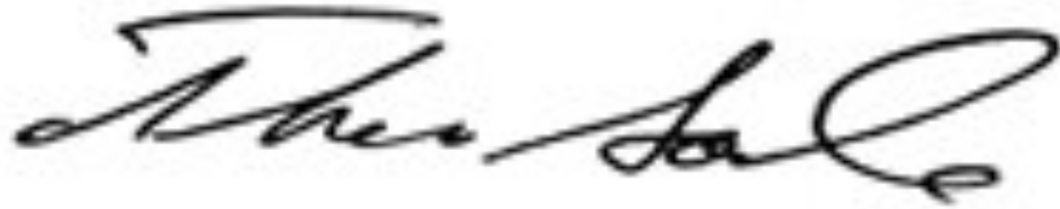

Thomas Goode
General Counsel
Alliance for Telecommunications Industry
Solutions
1200 G Street, NW
Suite 500
Washington, D.C. 20005
(202) 628-6380

September 17, 2021

Maine PUC Petition at p. 3.
This system is currently undergoing consolidation and any changes to the existing consolidation process must be approved by the FCC via its Change Order process.
See ATIS Comments on Petition for Additional Delegated Authority to Implement Number Optimization Measures in the 603 Area Code filed by the New Hampshire PUC at pp 2-4.

